3.1 >> fork() & getpid()

#include<stdio.h>
#include<sys/types.h>
#include<unistd.h>
#include<stdlib.h>
void main()
{
int pid,pid1,pid2,c_pid;
pid=fork();
if(pid == -1)
{
printf("Error in process creation \n");
exit(1);
}
if(pid != 0)
{
c_pid=wait(NULL);
pid1=getpid();
printf("Process ID of Parent = %d\n",pid1);
}
else
{
pid2=getpid();
printf("Process ID of Child = %d\n",pid2);
}
}
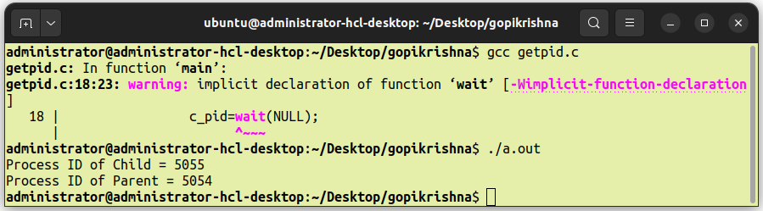
OUTPUT

3.2 >> exit()

#include<stdio.h>
#include<stdlib.h>
void main()
{
printf("Hello User !! \nLets start !! \n. \n. \n.\n. \nEnd !! \n");
exit(EXIT_SUCCESS);
}
OUTPUT
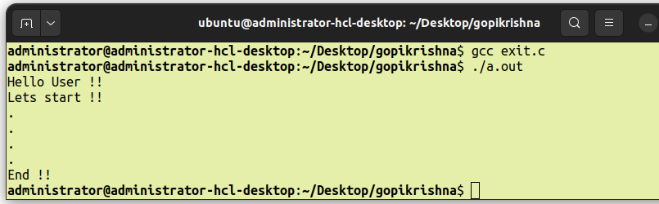
3.3 >> wait()

#include<stdio.h>
#include<stdlib.h>
#include<unistd.h>
void main()
{
pid_t cpid;
if(fork()==0)
{
exit(0);
}
else
{
cpid=wait(NULL);
}
printf("Parent PID : %d\n",getpid());
printf("Child PID : %d\n",cpid);
}
OUTPUT
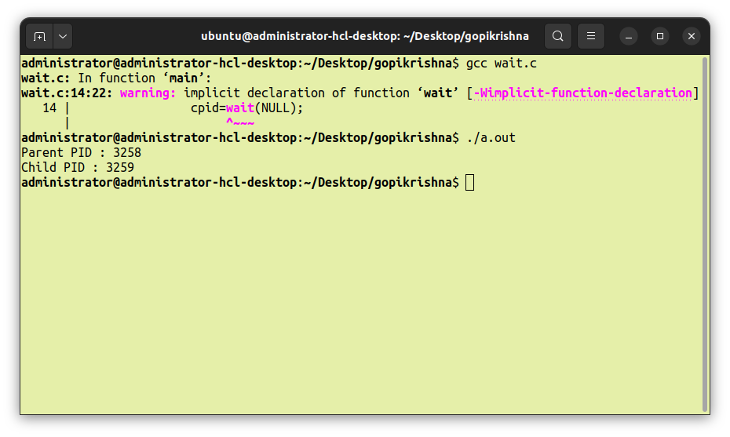
3.4 >> close()

#include<stdio.h>
#include<stdlib.h>
#include<fcntl.h>
int main()
{
int fd1=open("hi.txt",O_RDONLY);
if(fd1<0)
{
perror("c1");
exit(1);
}
printf("Opened the file discriptor = %d\n",fd1);
if(close(fd1)<0)
{
perror("c1");
exit(1);
}
printf("Closed the file discriptor.\n");
}
OUTPUT
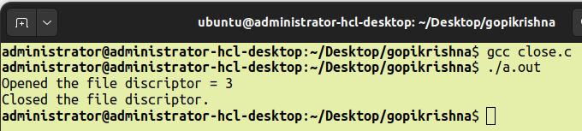

3.5 >> stat()

#include<stdio.h>
#include<sys/stat.h>
void main()
{
struct stat file;
stat("stat.c",&file);
printf("ST_Mode : %o \n",file.st_mode);
}

OUTPUT
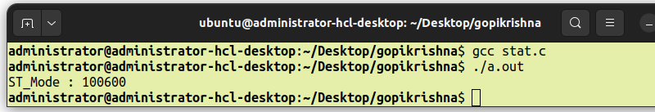
3.6 >> execl()

#include<stdio.h>
#include<unistd.h>
void main()
{
int pid;
pid=fork();
if(pid==0)
{
printf("EXEC STARTS");
execl("/bin/ls","ls","-l",(char)(0));
printf("EXEC DIDN'T WORK");
}
else
{
wait(0);
printf("PARENT = 'ls' is completed in CHILD\n");
}
}
OUTPUT
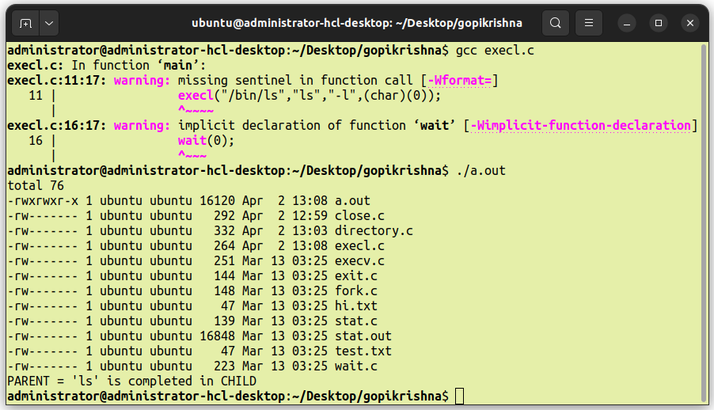
3.7 >> execv()

#include<stdio.h>
#include<unistd.h>
#include<stdlib.h>
int main(int argc,char *argv[])
{
printf("PID of execv.c = %d\n",getpid());
char *args[]={"HELLO","C","PROGRAMMING",NULL};
execv("./stat.out",args);
printf("Back to execv.c\n");
return 0;
}
OUTPUT
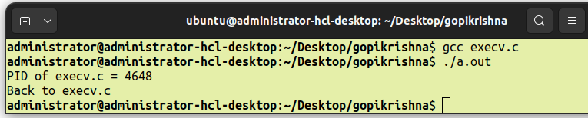
3.8 >> opendir() , readdir() & closedir()

#include<stdio.h>
#include<dirent.h>
int main()
{
DIR *folder;
struct dirent *entry;
int files=0;
folder=opendir(".");
if(folder==NULL)
{
perror("Unable to Read Directory");
return (1);
}
while((entry=readdir(folder)))
{
files++;
printf("File %d : %s\n",files,entry->d_name);
}
closedir(folder);
return 0;
}

OUTPUT
